|  |  |  |  |  |  |
| --- | --- | --- | --- | --- | --- |
| **Name of the Table** | **Table Description** | **Number of Fields** | **Primary Key** | **Related Tables** | **Foreign Key** |
| Supplier | Suppliers’ information | 7 | SupplierID | 1. Product |  |
| Inventory  Ledger | Inventory  Ledger | 7 | LegerID |  | 1. Product |
| Inventory  Details | Inventory  Transaction Details | 10 | DetailsID |  | 1. Product |
| Category | Category | 3 | CategoryID | 1. Product |  |
| Product | Product’ information | 9 | ProductID | 1. Category  2. Unit  3. Inventory Ledger  4. Inventory Details | 1.Supplier |
| Order | Order (Wholesale) | 3 | OrderID | 1. OrderDetail | 1. DateTage |
| OrderDetail | Order Detail | 7 | OrderID, ODetailID | 1. Order | 2. Product |
| Staff | Staff information | 10 | StaffID | 1. Order |  |
| Role | User’ role | 3 | RoleID | 1. Staff |  |
| Unit | Unit of product | 7 | UnitID | 1. Product |  |
| DateTag | Datetag | 12 | DateKey | 1. Order  2. Inventory Ledger |  |

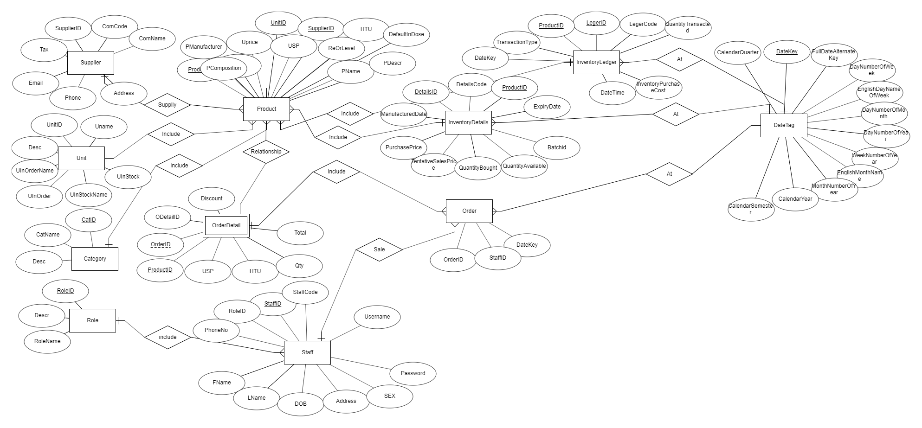

**Database Diagram **